Exercise 3
Task 1
1.2. Nominal categorical features : bluetooth, sim, screen
Ordinal categorical features : cores , speed , gen, wifi

Output csv file from 1.2,1.3,1.4,1.5,1.6 Task_1.3_1.4_1.5_1.6.csv

1.7
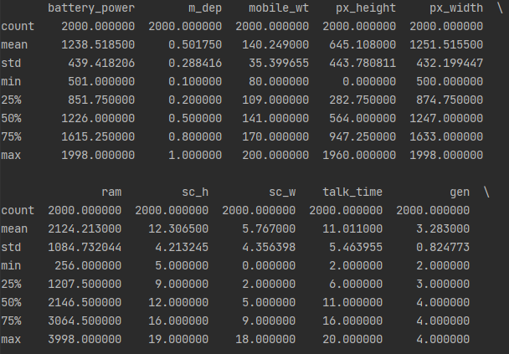
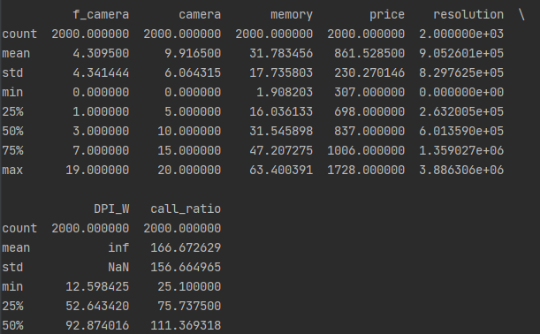
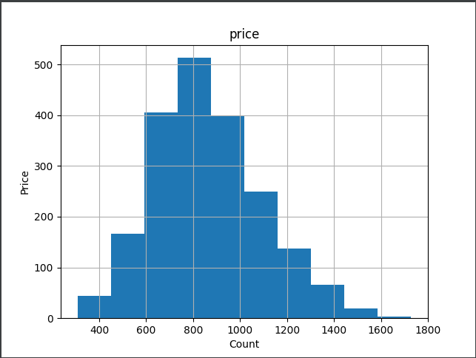
1.8

Task 2

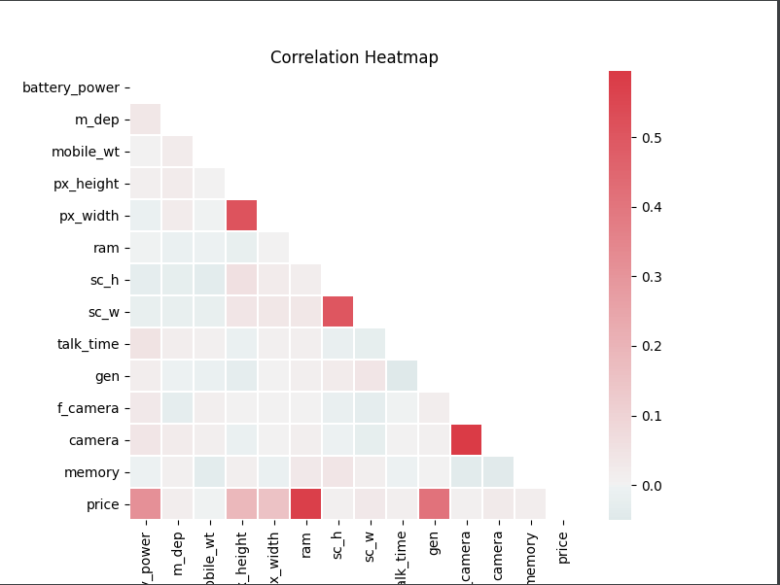
2.1

2.2 Features correlated with the device price shown in the matrix : ram, gen, battery_power

2.3
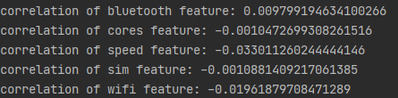
conclusion there is no correlation with price in the categorial features.
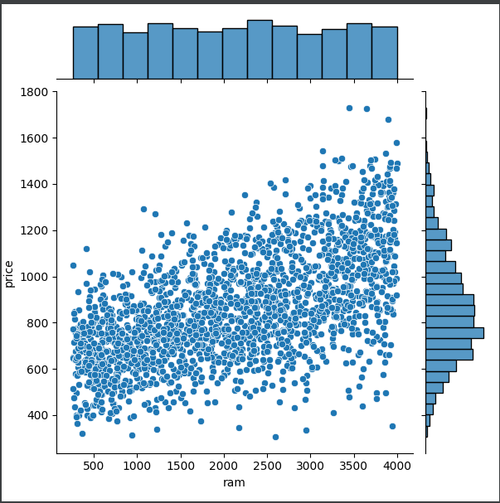
2.4

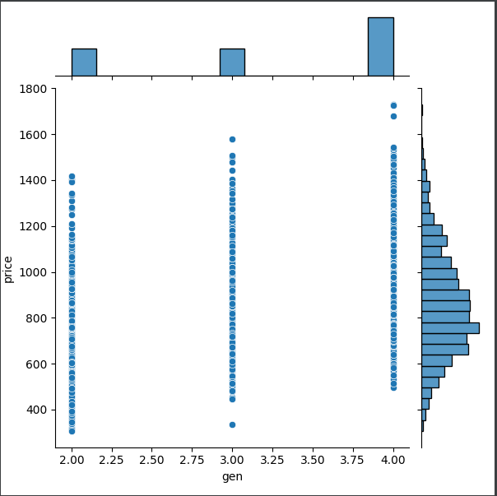
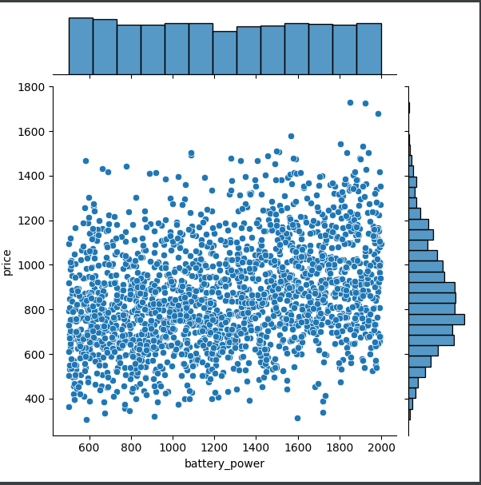
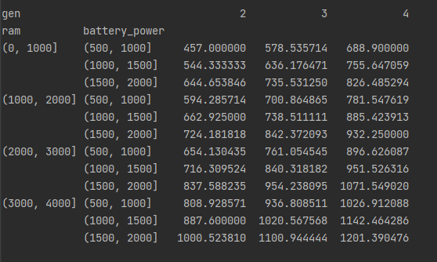
2.5

Task3
3.3 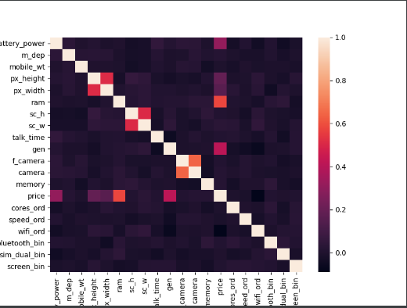

3.4 mobile_prices_converted.csv

Task4
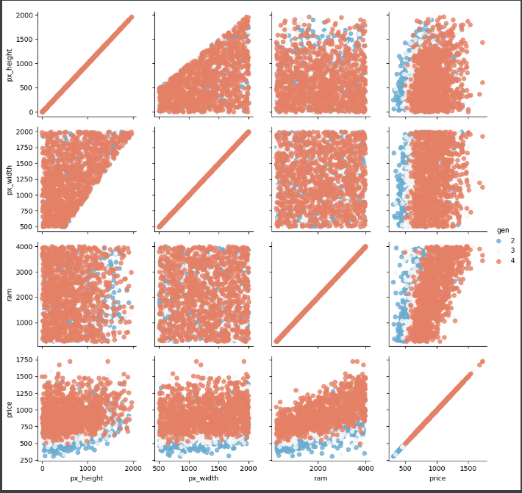
4.1

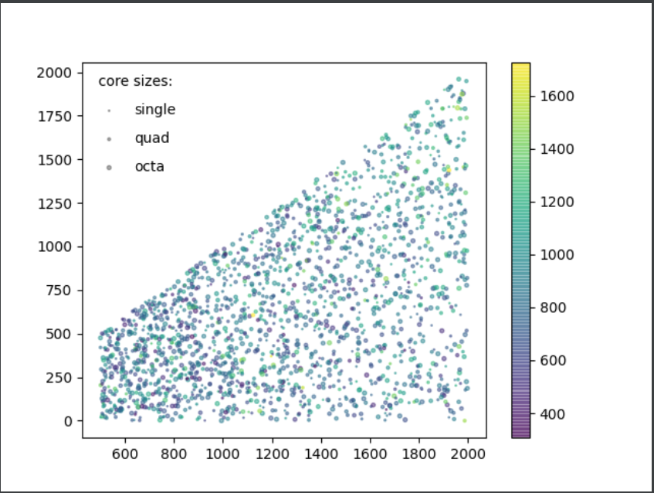
4.2.

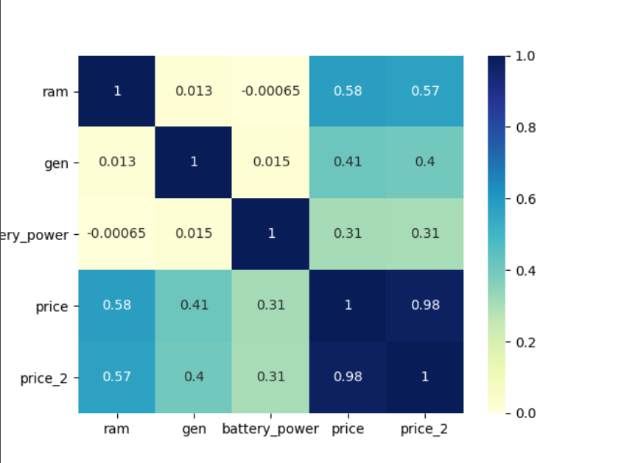
4.3

The most influential feature is the ram, the price is effected directly from the ram.

